**Lab Sheet 08**

Warnakulasinghe T.N

IT24102835  
  
1  
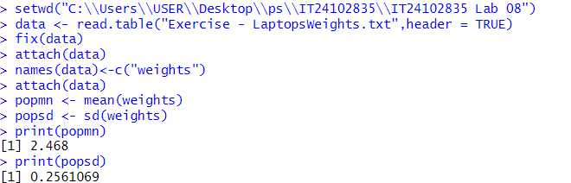

2

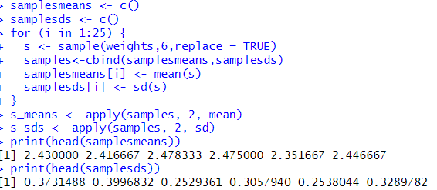

3

